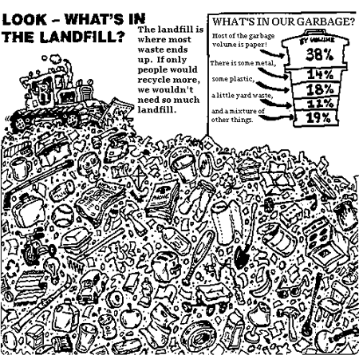
Waste….Look - What's In The Landfill?

ACTIVITY - FIND THESE THINGS IN THE LANDFILL SITE!
Color the items and cross out the words as you find them in the list below.
rubber tire  wagon  guitar  ball  ski pole  toaster  hockey stick | milk carton  chair  pop can  cardboard box  newspaper  stove  plastic bottle | running shoe  telephone book  ski  pants  rake  tricycle  shovel | apple  cup  lightbulb  lamp  yoyo  What else can you find?
A lot of these things could have been recycled or reused

